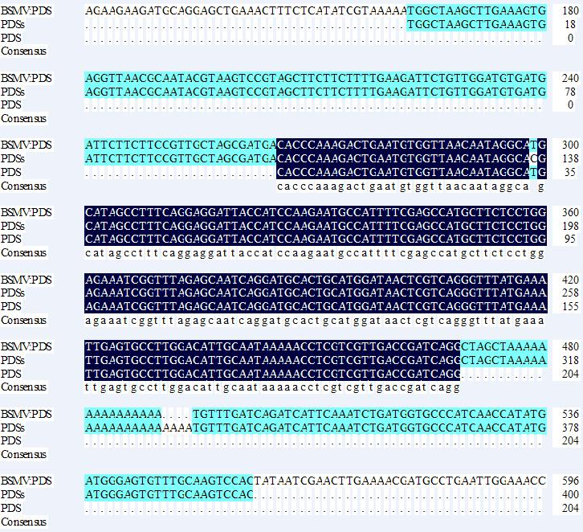

**Fig. S2** Sequencing result of the PCR product using PDSs from BSMV:PDS-inoculated plants.

Sequences in black background mean 100% similarity, represents for the *PDS* insert; sequences in green background mean 100% similarity, represents for the BSMV-γ. BSMV:PDS: sequencing result of the BSMV:PDS vector; PDSs: sequceing result of the PCR product using PDSs as the primer and the cDNA of BSMV:PDS-inoculated plants (45 dpi) as the template. PDS: sequence of *PDS* insert. The PCR products of 50, 55 and 60 dpi were also sequenced and showed the same results.