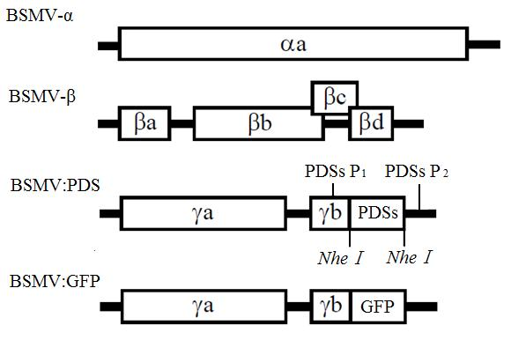

**Fig. S1** Schematic representation of barley stripe mosaic virus (BSMV) genome organization.

RNA β do not have the coat protein beta A deletion. The inserted PDS fragment is 200 bp in length and in an antisense orientation. The PCR primer PDSs are situated at both sides of the *PDS* insert on BSMV-γ and the predicted PCR product is 396 bp in length.